MIDTOWNERS SUNSHINE OF THE WEEK ► August 31st, 2007
Birthday of Rtn. Suresh Lal Shrestha on September 1st
Birthday of Secretary Isabella Bassignana Khadka on September 4th
Birthday of Sunita Joshi, spouse of PP Mani on September 2nd
Anniversary of Rtn. Peter and Kay Clawson on September 3rd
Anniversary of VP Navyo and Manju Eller on September 3rd

SPEAKER OF THE WEEK ► Om Prasad Yadav
THEME | Simple Tips on how to Take Good Photographs
Most of us snap-shooters feel that the picture we took of our pet dog or the party last weekend or during the trip to the mountain resort didn't come out very well. Although we can't get a post-card-perfect shot every time we can definitely increase the number of photographs that we would like to show off by remembering a very few simple things.
Om Prakash Yadav is a graphic designer by profession. Born in the South-eastern district of Siraha in 1974 in a farmer’s family, he moved to Kathmandu in 1984. After finishing his college he started learning photography by himself with the help of books and magazines. He was mostly impressed by the photographs in the ‘National Geographic’ magazine and thought that one day he too would take such photographs. His photographs are mostly of nature and life and the cultural heritage of Nepal.
Om believes in sharing his knowledge and takes young photo enthusiasts on photographic trips during the weekends. His works have been published in magazines, calendars, and brochures in Nepal and abroad. In 2006 he won the first prize in the ‘Nature and Wildlife photography contest’ organized by ‘Wildlife Conservation Nepal’.

UPCOMING SPEAKERS ► PREVIEW
DATE | SPEAKER | THEME
Sept 7th | H.E. the Malaysian Ambassador to Nepal | Dinner Meeting
Sept 14th | PP William Ma | Orientation about Rotary
Sept 21st | Shyam Thapaliya | Tourism Entrepreneurship

THE MID-TOWN CLUB ► NEWS
Last Week’s Speaker

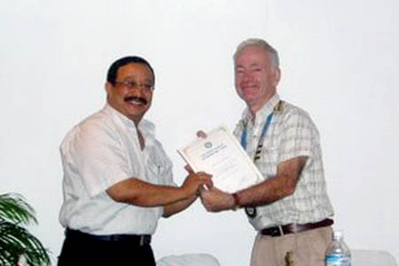
Guest Speaker Dr. Pramod Shrestha receiving Letter of Appreciation from President Walter
SCENES FROM LAST WEEK’S MEETING
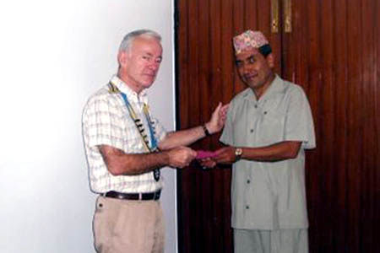 | 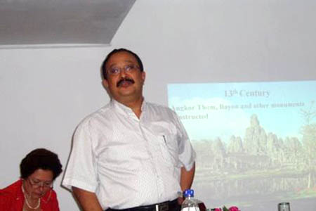
President Walter handing check of Rs. 30,000 to Mr. Raghunath Thapa from RCC Lele for Girl Child Education | Dr. Shrestha talking about Cambodia

THE ROTARY INTERNATIONAL ► Over a Century of Rotary
Important Milestones in Rotary History
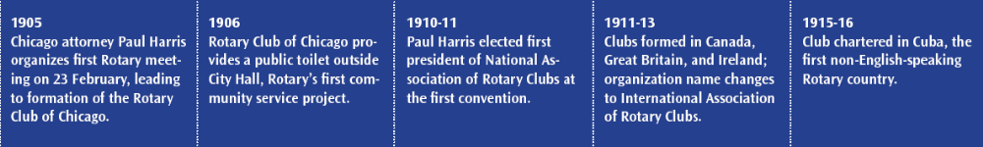
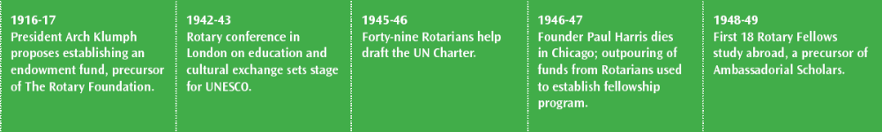
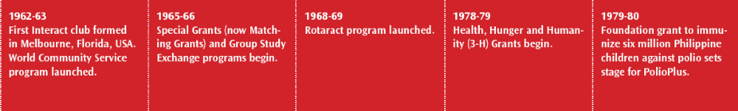
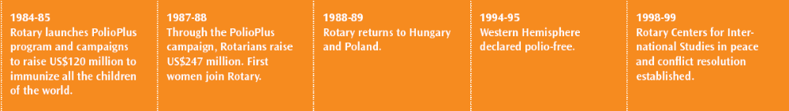


Editor: Rabi Karmacharya, Club Service Director email: rabikarma@gmailcom
----- Original Message -----
From: "Rabi Karmacharya" <rabikarma@gmail.com>
To: <undisclosed-recipients:>
Sent: 30 August, 2007 15:25
Subject: BC Vol 9 07-08

Dear Mid-Towners.
Here is this week's Breakfast Chatter.
Hope to see more of you at our breakfast meetings. The turnout has been
quite dismal over the past few weeks, with only about 35-40% of the
members attending the meeting. As a Club Service Director, it is quite
discouraging to bring in speakers to talk to a thin audience. I would
appreciate your feedback on what can be done to increase attendance in
our meetings.
Tomorrow we have a young photographer who will give you tips on how to
take good photographs using your run-of-the-mill point and shoot
cameras. I think it will be quite helpful to most of us.
Also note that next week we have dinner meeting instead of regular
breakfast meeting. His Excellency the Malaysian Ambassador will be our
special guest. The dinner will be held at Malla Hotel. Details to follow.
Cheers.
-Rabi
Club Service Director
Rotary Club of Kathmandu Mid-Town 2007-08

